**LINUX COMMAND PRACTICE 2**

B. COPY, RENAME AND EDIT FILES

14. Create the following files using nano (or another editor): song.doc (write a few lines of a song) in the directory Egypt; tv.doc (write the name of your favourite TV programs) in the directory Seul and marks (write the marks you expect to get this year) in the directory Tunisia.

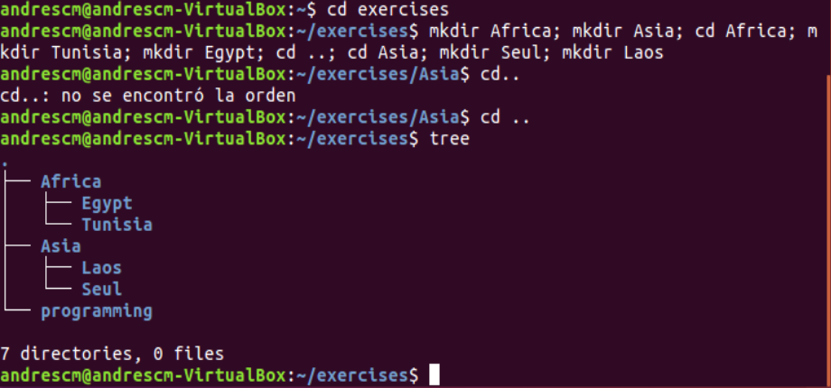

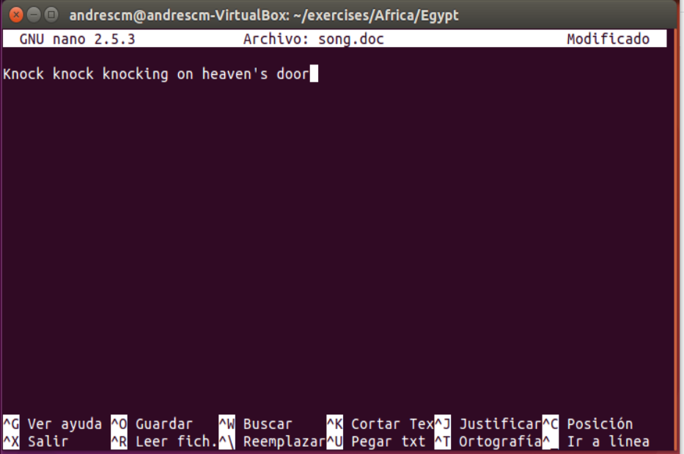

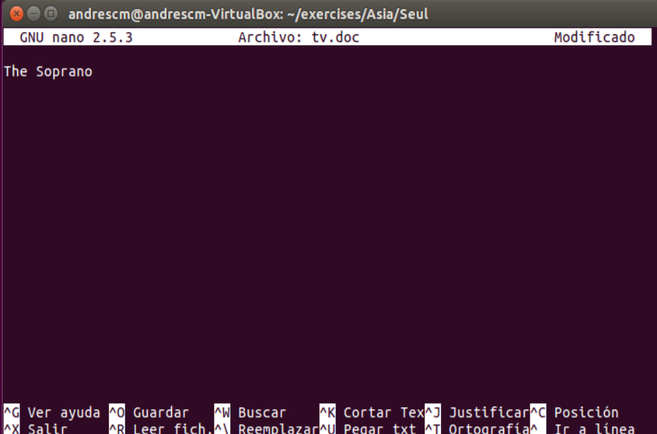 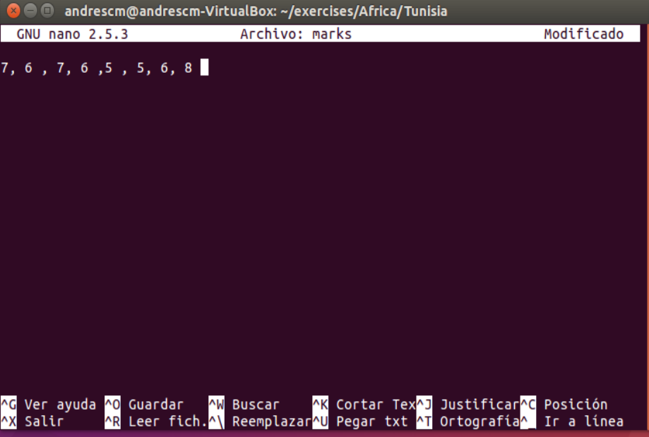

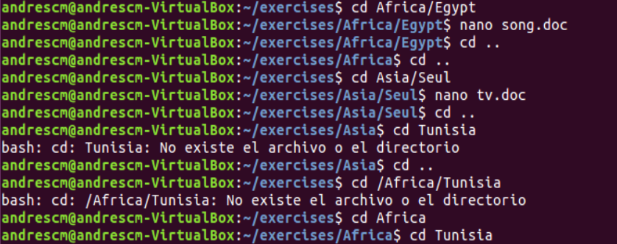

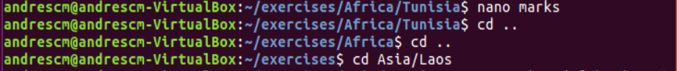

15. Copy the file “song.doc” into “Laos”

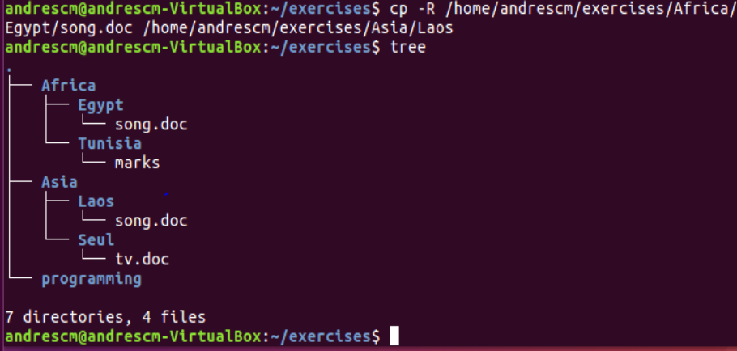

16. Copy the file “tv.doc” into “Egypt” with the name “radio.txt”

*( Here i have a problem, i’ve used mv instead of using cp and then,when the directory is created in Egypt file change the name with mv /home/andrescm/exercises/Africa/Egypt/tv.doc /home/andrescm/exercises/Africa/Egypt/radio.txt )*

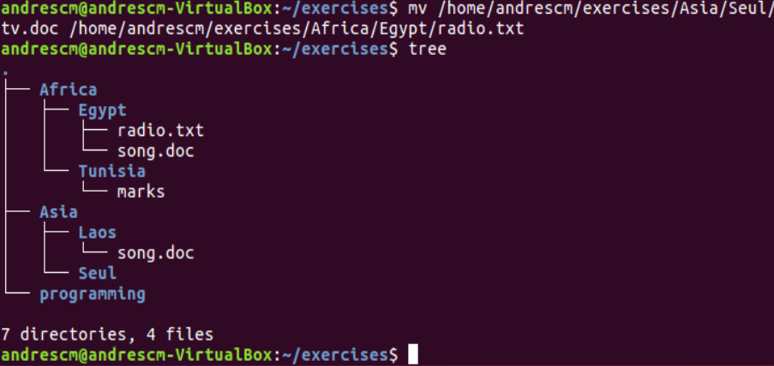

17. Rename the file “marks” to “exam.wri” (it is located in the directory named Tunisia)

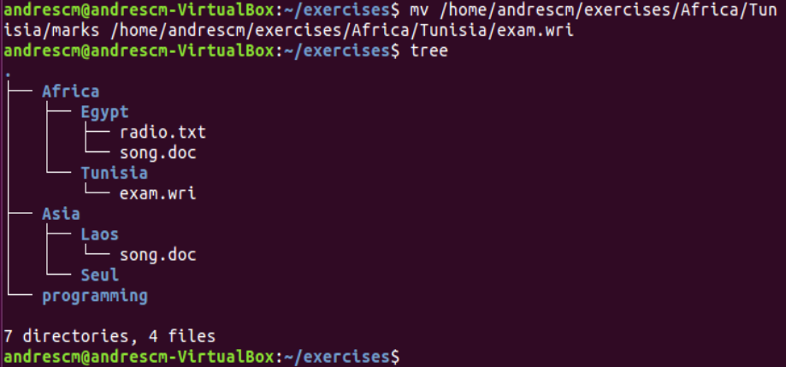

18 Copy the file “song.doc” (located in “Egypt”) inside “Tunisia”

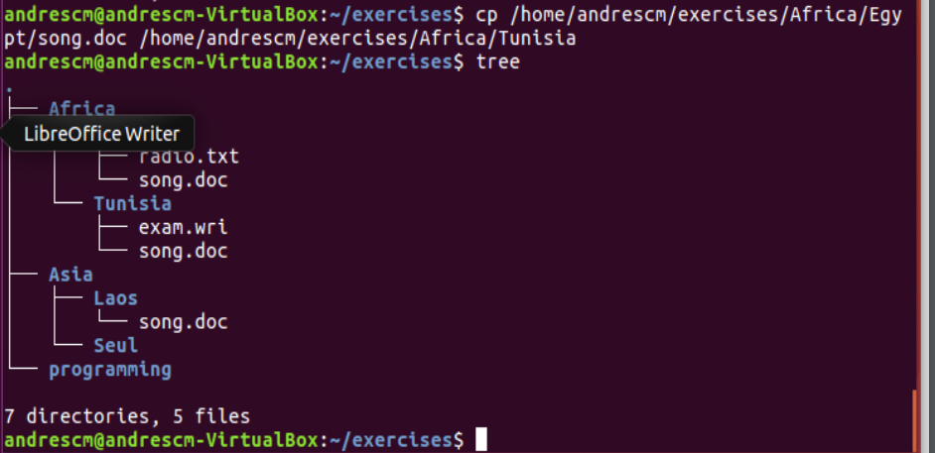

19. Print the content of the current directory using long listing format

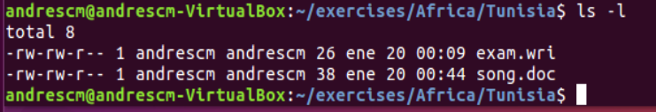

20. Rename the file “song.doc” (located in “Laos”) to “aa.doc”

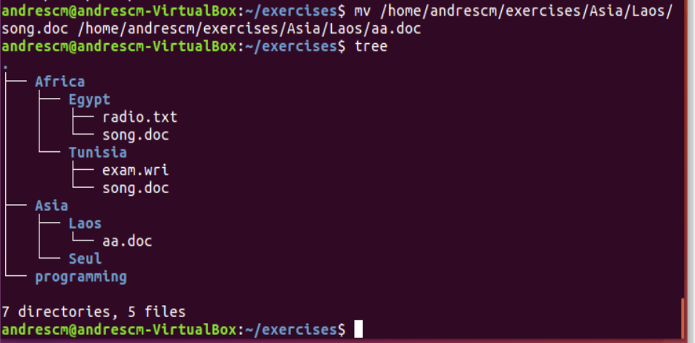

21. Create the directory “Others” in “Laos”

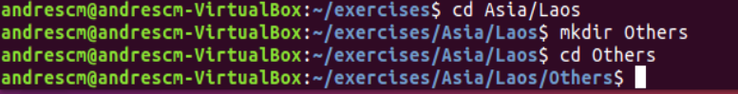

22. Rename the directory named “programming” (which you created in the first exercises) to pro-c.

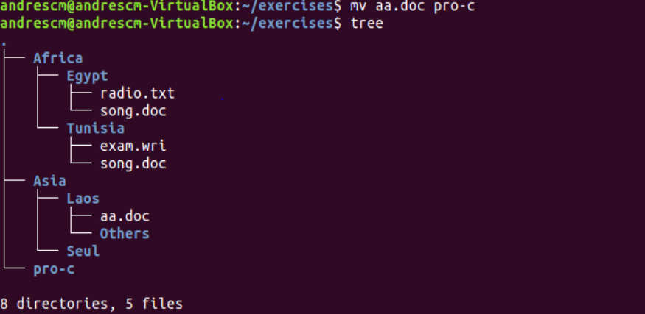

(sorry, i made a mistake with the name and i have changed to aa.doc at first, that`s why it shows that name)

23. Create the following directory tree in “exercises” (using as few commands as possible)



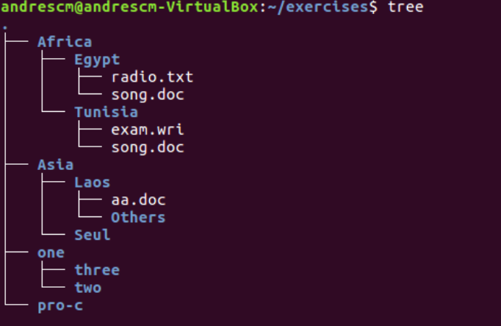

24 . Copy the files with txt extension from the directory named “systems” to “exercises”

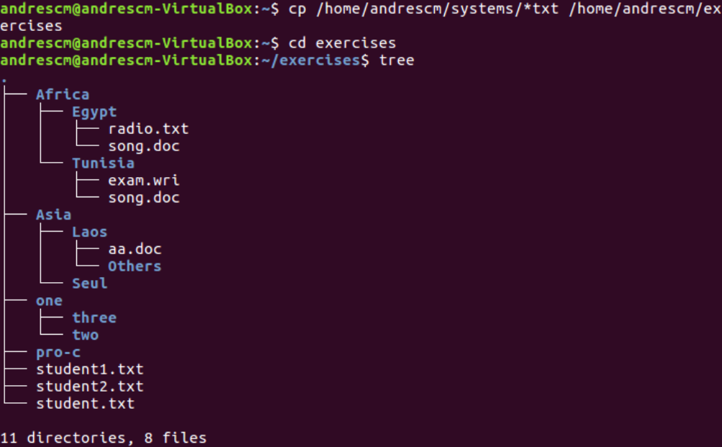

25 . Move the files you copied in the exercise above to the directory THREE

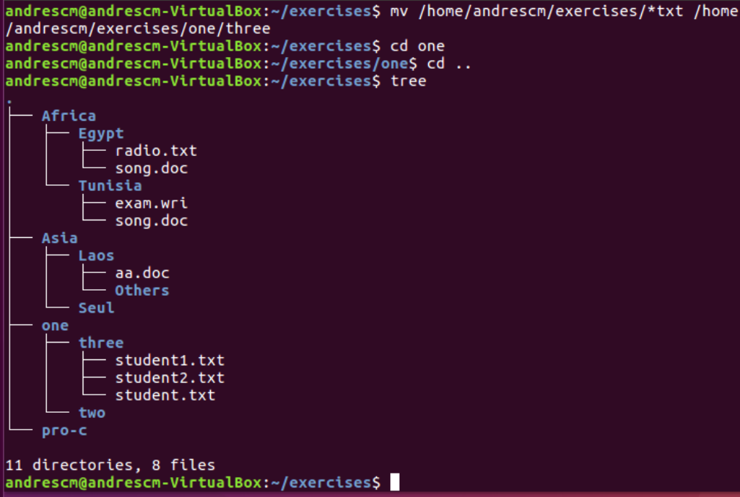

26. Delete the directory named THREE, including all the files and, if so, subdirectories´

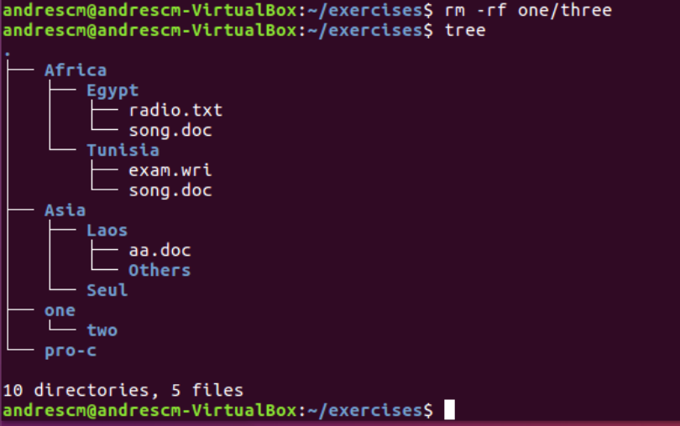

**CHANGE INTO SYSTEMS AND DO THE FOLLOWING EXERCISES USING ABSOLUTE PATHS**

27. Copy the files that end with “txt” of the directory named “systems” to “Tunisia”

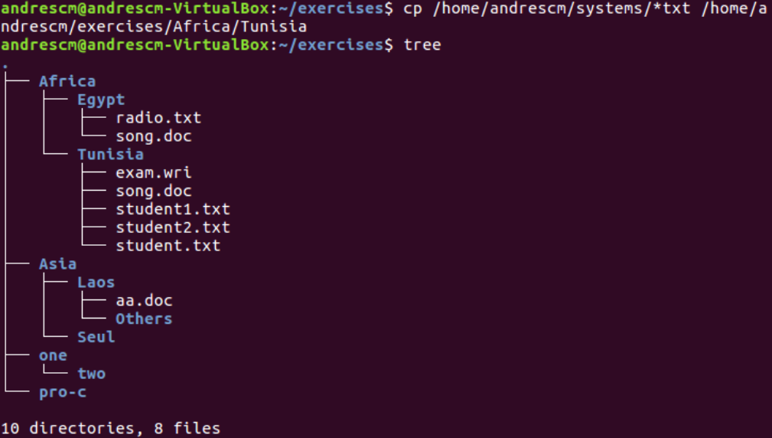

28. Copy the file “tv.doc” (located in “Seul”) to the directory named “exercises”

*( Problem in number 14. I solved it creating the tv.doc in Seul to continue the exercises)*

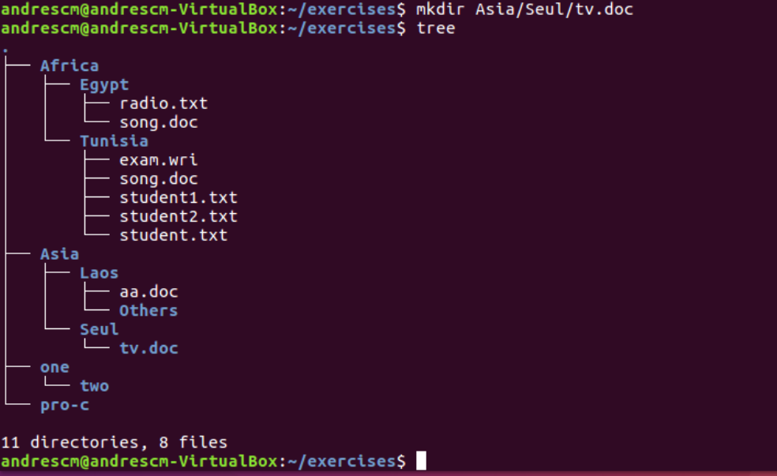

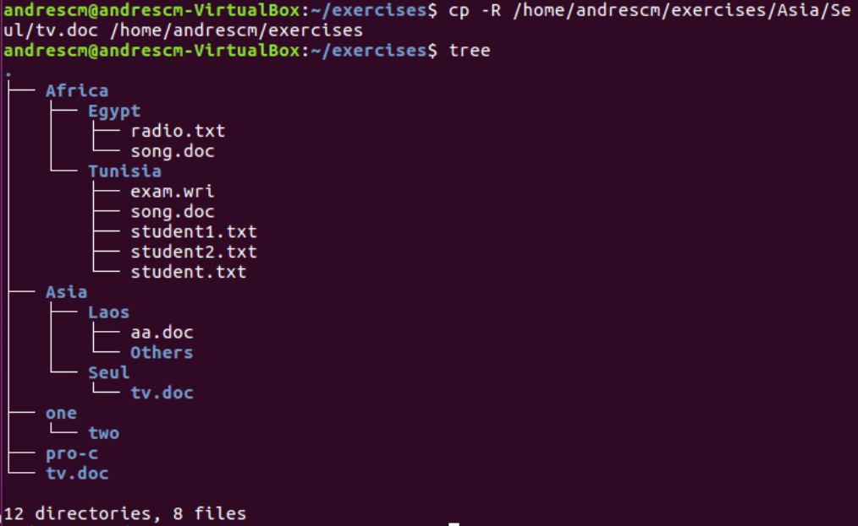

29.Rename the file student1.txt (located in “Tunisia”) to tuition.txt

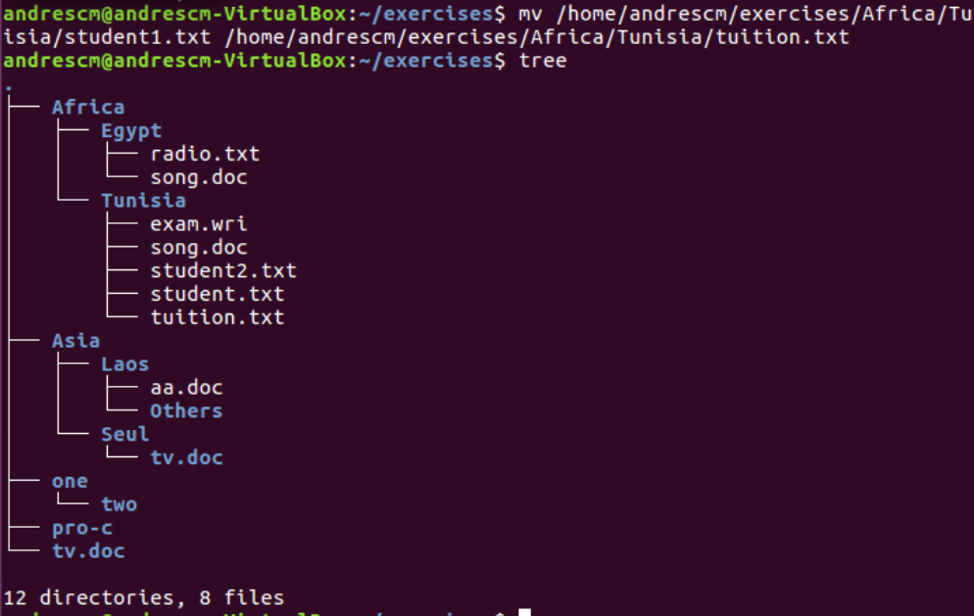

30. Create a new directory called “earth” into “systems”. Create another directory called “countries” inside “earth”

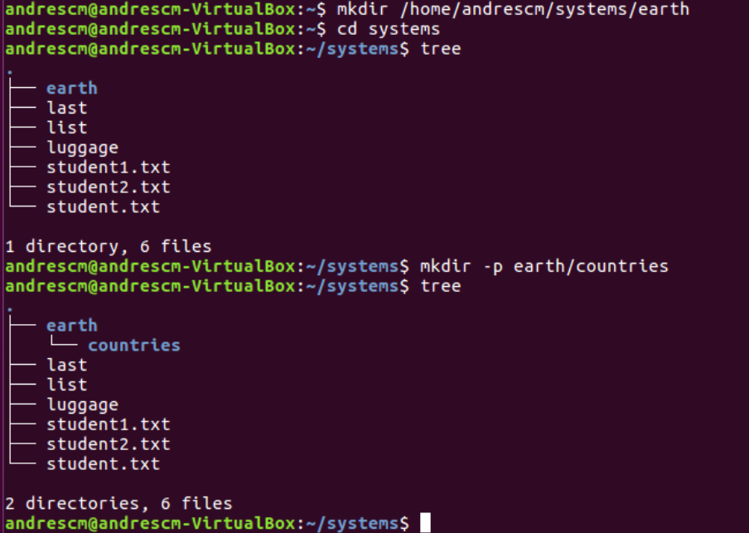

31. Rename “Africa” (located in “exercises”) to “Afri

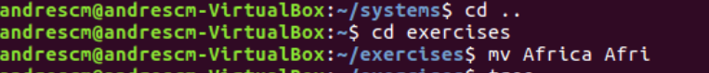

**NOW YOU CAN BE PLACED IN THE DIRECTORY YOU WANT 32.**

32.Move the file “song.doc”, which is located in Egypt, to “Laos” with the name “bb.doc”

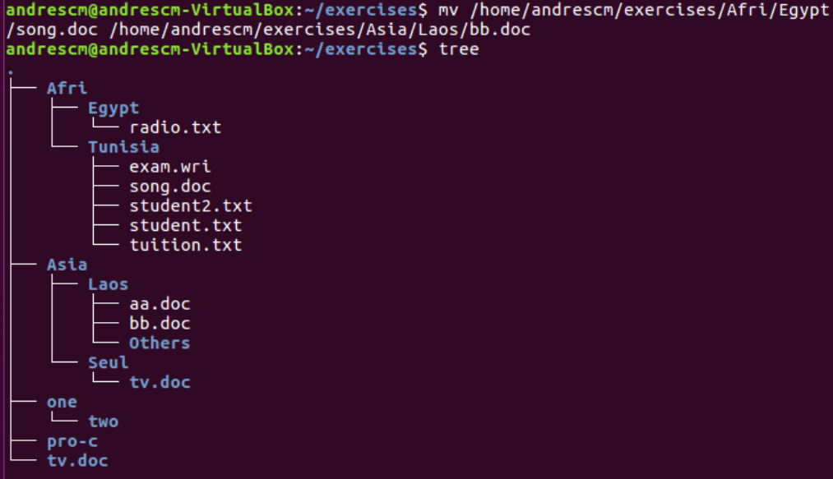

33. Copy the files whose name contains the letter “u” from “systems” to “exercises”



34. Print the content of the /etc directory, including subdirectories, in reverse alphabetical orde



35. How can you print the name of the current directory?



36. Copy the folder “Afri” including files and subdirectories to “Asia”

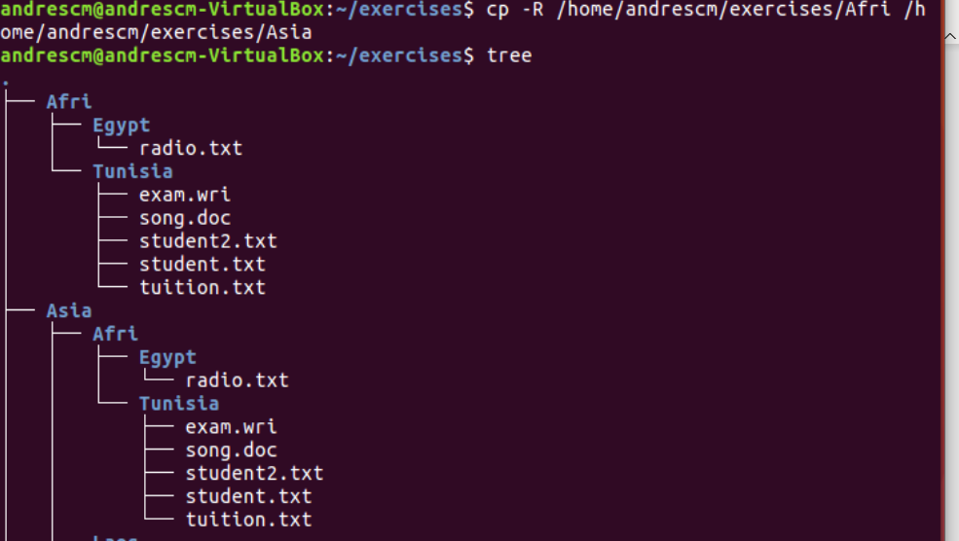

37. Move all the files and subdirectories of “Laos” to “Seul” and rename it to “Seul2”



